**A Study of Contemporary Mobile Processors Architecture**

Chunan Shen G47757834

George Washington University

**ABSTRACT**

Today the computing landscape is significantly different from before: growth in tablets and smartphone is surpassing that of desktops and laptops. However, the battery technology doesn’t keep up with the evolution of mobile CPU. Energy and power are now the primary design constraints. This paper studies the architecture of contemporary mobile processors based on both ARM and X86 ISA, focusing on their improvement from tradition desktop CPU and effects on power efficiency and performance.

**INTRODUCTION- A BRIEF HISTORY OF MOBILE PROCESSORS**

The boarder between traditional computers and mobile devices has been blurring. Users now work with products such as smartphones and tablets to access the Web, send and receive email, compose documents and play games. Because of the fast evolution of mobile processors, all of these became possible in the past decade.

**1996 – In the beginning**

It’s 1996, in Finland, Nokia launch the world’s first smartphone, Nokia 9000 Communicator. It was driven by an Intel 80386EX, which is variant of 80386SX, intended for embedded system. The CPU has a clock rate up to 24MHZ, and support 26 bits memory addressing for up to 64 MB of DRAM. The Communicator had a mere 8 MB of memory: Half of which was used for apps, 2 MB for program memory and 2 MB for user data.

**2007– Touch Screen and IOS**

It’s 2007 that touch screen smartphones and the emergence of a big screen really pushed developers and component makers to keep pace with this ramp up. Typically these power hungry machines needed a 620 MHz CPU and used 128 MB of memory.

In this year, iPhone, one of the first phones to use multi-touch screen, was introduced to the market coming with a Samsung produced ARM-based CPU. It has a clock rate up to 620 MHZ, and 32kb L1 cache. This phone also configured with 128MB DRAM and independent PowerVR MBX Lite 3D GPU. The powerful data and graphic processing ability give more freedom for user and developer. And the successful of IPhone start the new era of mobile computing devices.

**2008- From It to Them**

With smartphones becoming increasingly sophisticated, the need for more computing power in a smaller space became paramount.

In a traditional desktop PC, the CPU, RAM, graphics card and storage are scattered pieces on a motherboard. However, the space inside mobile devices is very limited and most of them are taken by battery. To overcome this challenges, Qualcomm launched the first System on a Chip (SoC)-Snapdragon S1, putting CPU, GPU, Wireless Unit and some other necessary components on a single chip, for mobile devices.

The first generation Snapdragon has an average performing 2 cores CPU with a maximum clock speed of 528 MHz, resulting in good multi-tasking compared to a single core processor. Its RISC-based design enables instructions to execute faster. It also introduces a companion CPU core to handle less intensive tasks, which runs at a lower clock speed and hence consumes less power making the SoC more energy efficient.

**2014 – Snappier than ever**

We now have the smartphone powered by latest Qualcomm Snapdragon 800, Apple A7 and some other cutting-edge processors. At 28nm, these processors take die shrinking to a new level, balancing performance and power efficiency more sophisticated. And make the mobile devices much faster and more versatile, too. The phones we are using today have hundreds of times more memory and faster speed than the original Nokia Communicator.

**MOTIVATION**

Far more than phones, they are "integrated platforms for providing seemingly disparate technologies that have come together to provide a new user experience." And "The heart of it is a mobile processor that must be married together with power management ICs, with RF, sensors, display, and battery, into a small form factor that has to be light and low cost," said Scott Runner, vice president of advanced methodologies and low-power design at Qualcomm, at DAC 2013. So what are the challenges we face today in mobile processor design in order to meet such requirement.

**Power Management**

Power is the most critical design constraint of any mobile platform as it determines everything from battery life to size and weight. Today’s user expects mobile devices to be small, lightweight, and portable with all-day battery life regardless of the application. Unfortunately, battery capacity has not increased enough to maintain pace with the demand for more powerful computing platforms. CPU power consumption must be kept to an absolute minimum and power-demand techniques must be implemented to respond to the varying levels needed. First and foremost, we must realize this is a system design problem. That requires an awareness of system architecture, workload partitioning, hardware/software partitioning, and power modeling and optimization. Also, there's a need for effective power management strategies - such as dynamic CPU and GPU control, dynamic voltage and clock scaling, and power gating. We need to determine where return on investment is best.

**Performance and Space Control**

As always, performance and space is an inherent paradox in CPU design. It just becomes more prominent in mobile processor due to its very limitation of space. Nowadays mobile devices are performing many more computing-related tasks than in the past, which place higher requirement on the chips that run them. The latest IPhone was equipped with a 28nm process SoC that integrates more than one billion transistors on a die 102mm2 in size. Moore's law is also observed and confirmed in the mobile chips industry. It's going to be a problem how can we manage so many transistors on such a small area and what function should we integrate on chips. And Heat dissipation is a problem often associated with high-performance CPUs. A Lack of space inside of mobile device makes it impossible to add any new cooling device. Creative techniques must be taken to ensure that heat does not relegate the device to the defective pile.

**Memory and Cache**

The demand for increasing memory channel bandwidth is mounting rapidly in devices such as smartphones and tablets. The LPDDR3 standard, published in May 2012, offers a higher data rate, improved bandwidth, better power efficiency, and higher memory density compared to LPDDR2. However the reality that software is growing faster than hardware. And those applications are consuming resource much faster than we expected. Thus memory performance could become the biggest bottleneck in mobile device. In order to address the situation, new solution must be provide to utilize the memory and improve the performance.

And there are some other constraints for mobile processors design, like integration complexity, verification/validation, and hardware/software compatibility, cost, manufacturability, and reusability of the design. But they are way beyond the topic studied in paper. Thus they will not be addressed here. The aim of this paper is to enable readers to get insights into the real-world techniques for improving processor performance and power efficiency, and inspire them to invent novel solutions addressing those problems.

**MOBILE PROCESSOR ARCHITECTURE**

After a quick review of mobile processor development history and constraints, we now go deeper to look at the infrastructure and Architecture of mobile processors. In this paper, we will use the most widely accepted processors as reference. Based on the market analysis form Strategy Analytics, “Qualcomm, Apple, MediaTek, Samsung and Spreadtrum captured the top-five revenue share spots in the smartphone applications processor market in 2013” and “Intel captured a minor 0.2 percent revenue share in the market”. Even thorough Intel now is at the following position, no one can under estimate their R&D ability and ambition. And Intel Atom is the flagship of X86 based mobile processor. Hence, it will also be included in the study. Table 1 shows the configuration of chips form those major suppliers.

**Table 1 Contemporary Mobile Processors Configuration**

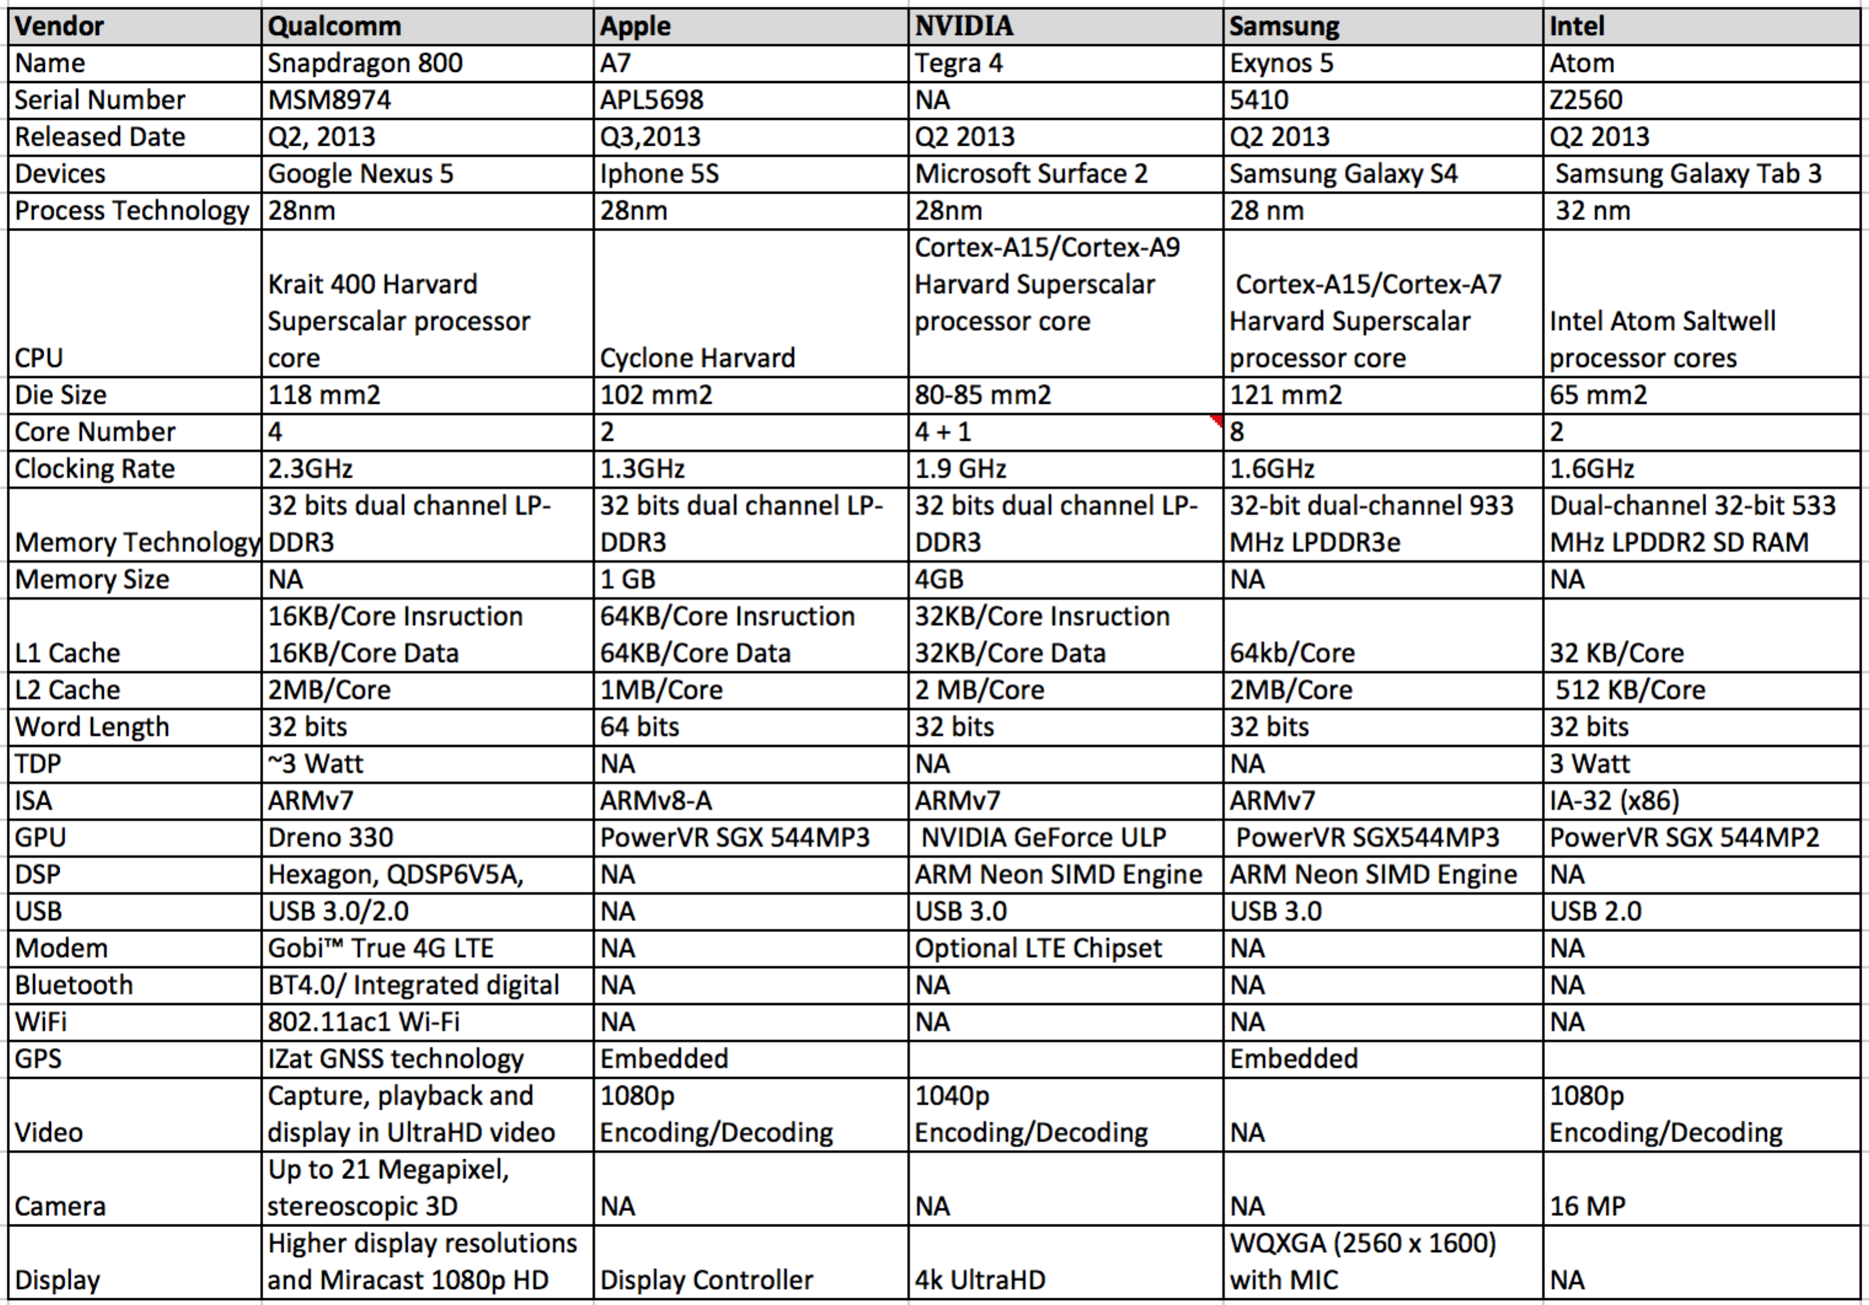

**SoC Paradigm**

Unlike the CPU in PCs, the mobile processor in your device is way more than a CPU. It’s named as System on Chip (SoC), which is an integrated circuit that integrates all or part of components of a computer or other electronic system into a single chip. Figure 1 below shows the structure of a standard SoC.

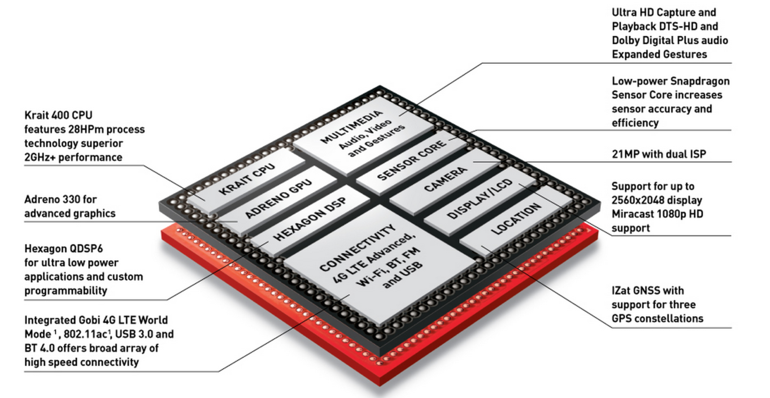

**Figure 1 Qualcomm Snapdragon 800 SoC (Source: Qualcomm Snapdragon website)**

Why should we use SoC to replace the traditional Chip on Board architecture? This comparison of SoC (NVIDIA) and CPU (Intel) based MS Surface tablets could partially reveal the answer.

**Table 2 Comparison based on Microsoft Surface (Source: Microsoft Surface website)**

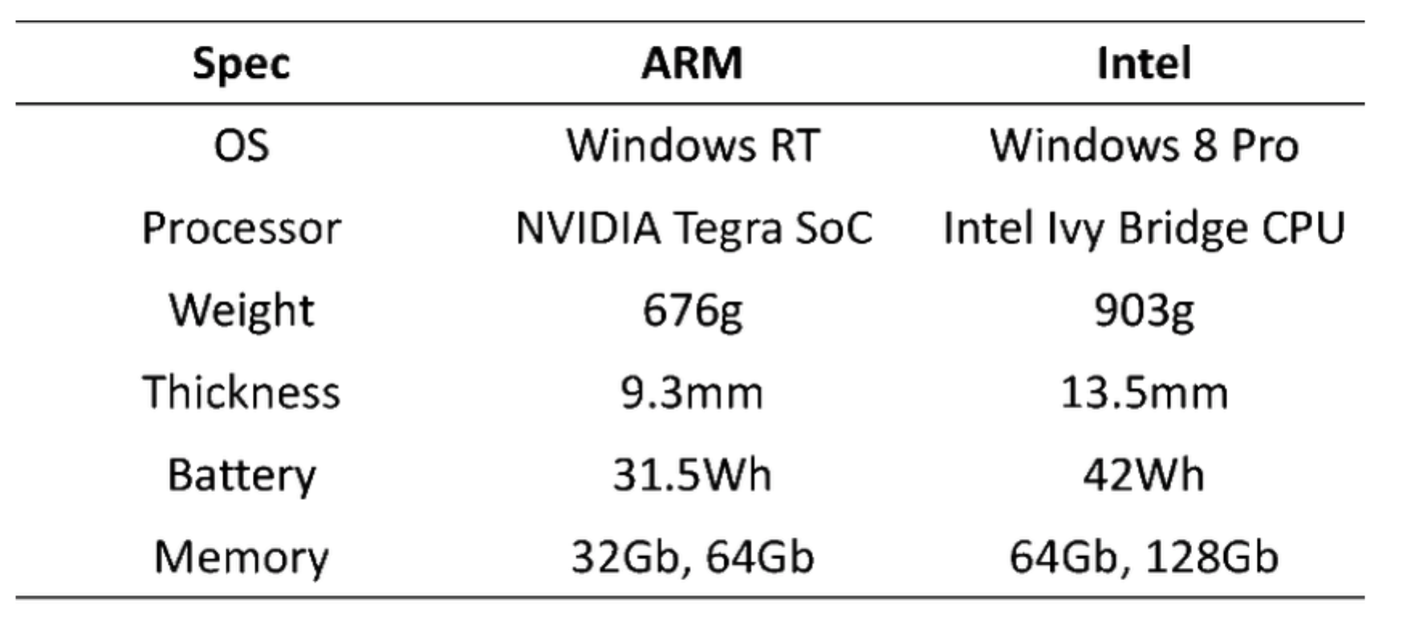

The CPU based design relies on extra chips to achieve the necessary hardware integration resulting in a 30% heavier and 40% thicker product form factor. It is also interesting to note that the NVIDIA SoC design is made using lagging 40nm lithography while the Intel CPU design is made using the two generation more advanced 22nm lithography.

In addition, by moving more functionality to hardware, the SoC enables lean software, which results in lower system-level power. Using dedicated cores enables the smartphone to only turn on specific blocks for specific tasks whereas a general-purpose core would have to be on all the time regardless of the task being performed. A system-on-chip is thus far better suited for mobile devices compared to a stand alone CPU.

Generally specking, the advantages offered by SoC technology [1] include: 1) Power efficiency 2) higher performance, since all the circuits will be on a single chip; 3) smaller space requirements; 4) lower memory requirements; 5) higher system reliability; and 6) lower consumer costs.

In less than 10 years, the SoC technology has catapulted from enabling basic computation/connectivity on a feature phone to being at the heart of all mobile devices, capable of a wide range of functions including audio/video, gaming, communication and productivity.

**Multi Cores CPU**

Experiment shows that the digital workload of a smartphone (all control, data and signal processing) amounts to nearly 100 giga operations per second (GOPS) at 2010. This workload increases at a steady rate, roughly by an order of magnitude every 5 years. Meanwhile, Li-ion batteries provide about 800mAh at 3.7V, or nearly 3Wh. In smartphone, more power is required for PA and RF. Also, hundreds of mWs are required for the display backlight. All this leaves only about 1W for the digital workload of 100GOPS [2]. Thus the limited available battery power is the dominant determinant of the multi-core architecture for mobile phones.

**Table 3 Mobile Phone Trend in 5-Year Intervals**

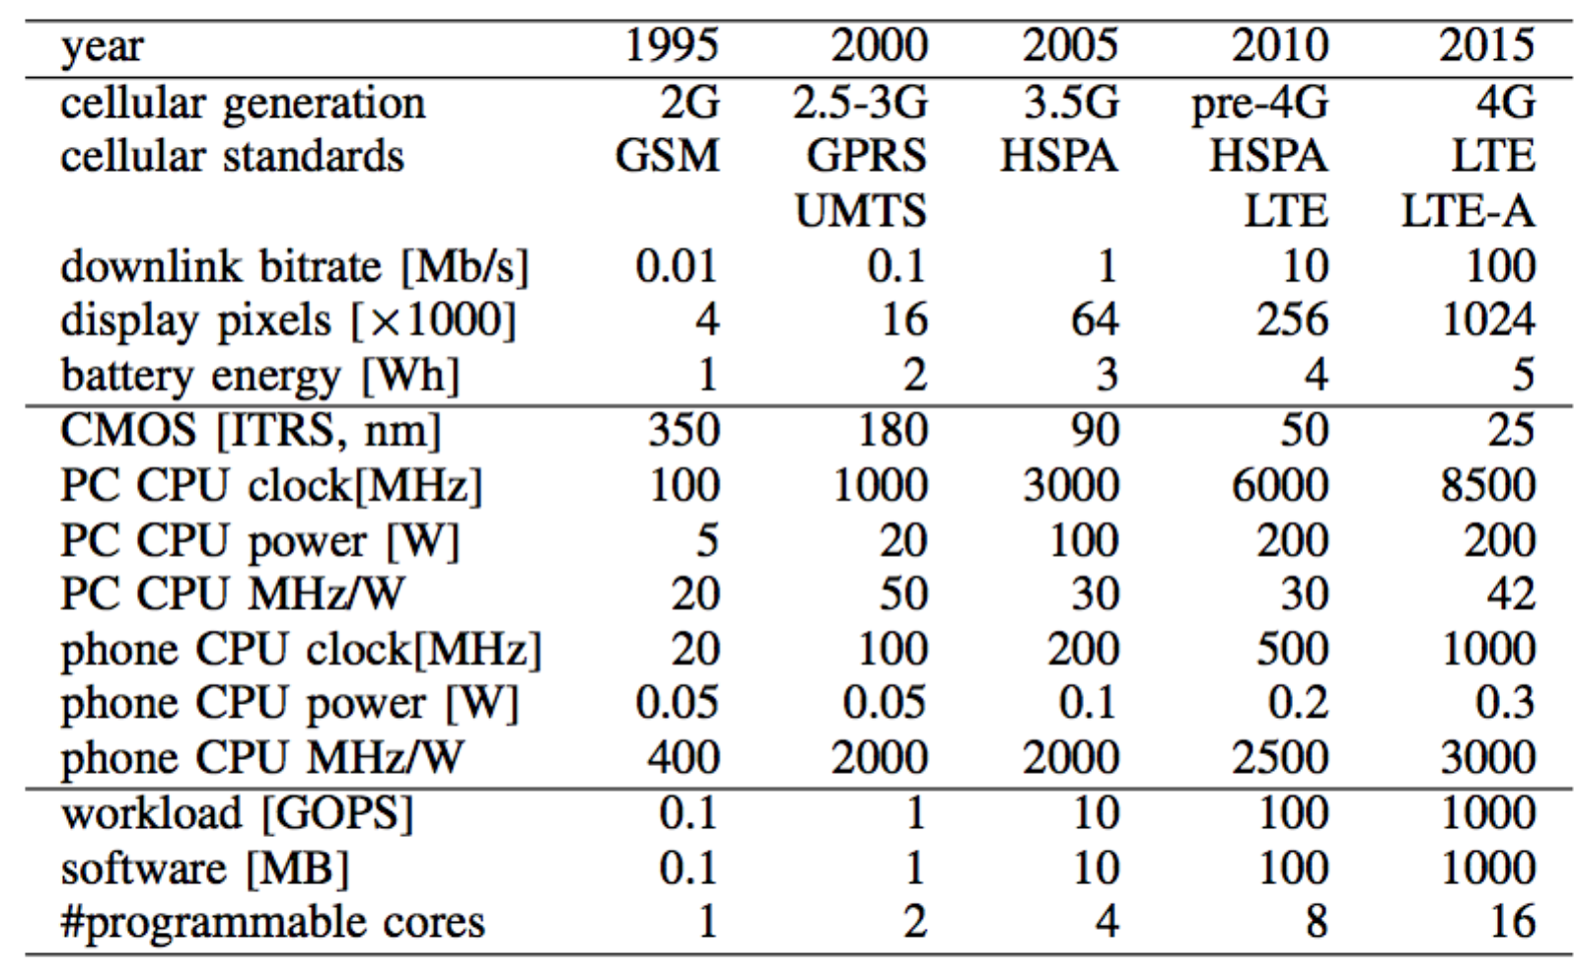

The only way out is a heterogeneous architecture based on less or more specialized programmable cores. Mobile use case studies show that most mobile devices are typically in active standby state for eighty percent of the time, and process intensive mobile applications twenty percent of the time. Taking NVIDIA Tegra 4 in table one for example, the Companion core, which is optimized to minimize active standby state power consumption, and handle less demanding processing tasks, is designed on a low power process technology, but has an identical internal architecture as the main Cortex A15 CPU cores. Since it is built on a low power process in the low performance ranges (and frequencies), it consumes lower power than the main CPU cores that are built on a fast process technology. Unlike the Companion core, the main CPU cores need to operate at very high frequencies to deliver high performance. Therefore they are built on a fast process technology, which allows them to scale up to very high operating frequencies at lower operating voltage ranges.

When the Companion core is turned off and the mobile processor is using the main cores for processing, the CPU Governor and CPU management logic continues to monitor CPU workload and utilization of each of the main cores, dynamically enabling or disabling one to four of the main cores. Figure two explain the different working stages of a multi-cores CPU.

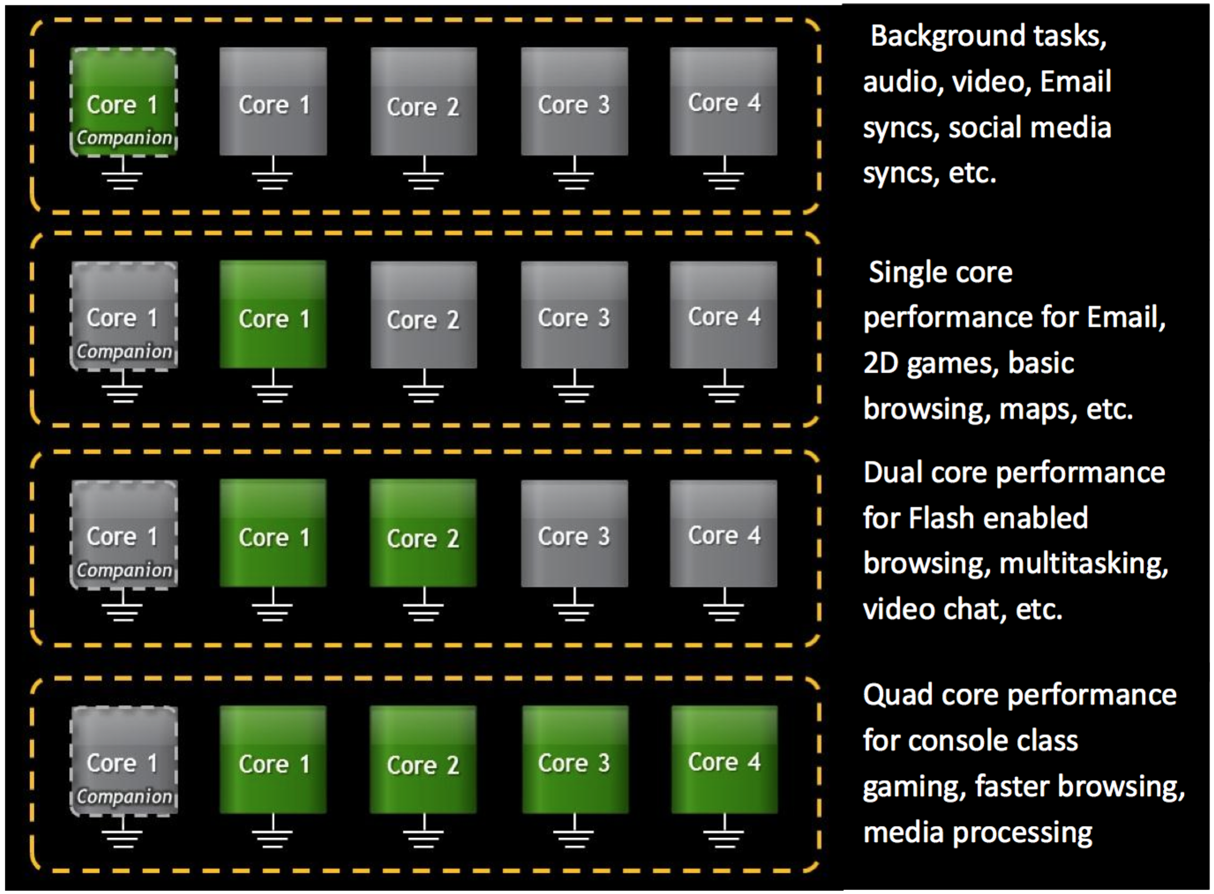

**Figure 2 CPU cores management based on workload (Source: NVIDIA website)**

Generally speaking, in mobile SoC, more cores are better for power management than fewer cores. The reason is that four cores can run at a much lower frequency, and hence lower voltage when processing the same amount of work as a dual core CPU. Since power is proportional to the square of the voltage, the overall CPU power can be significantly less – and still complete the same amount of work. See figure 3 below:

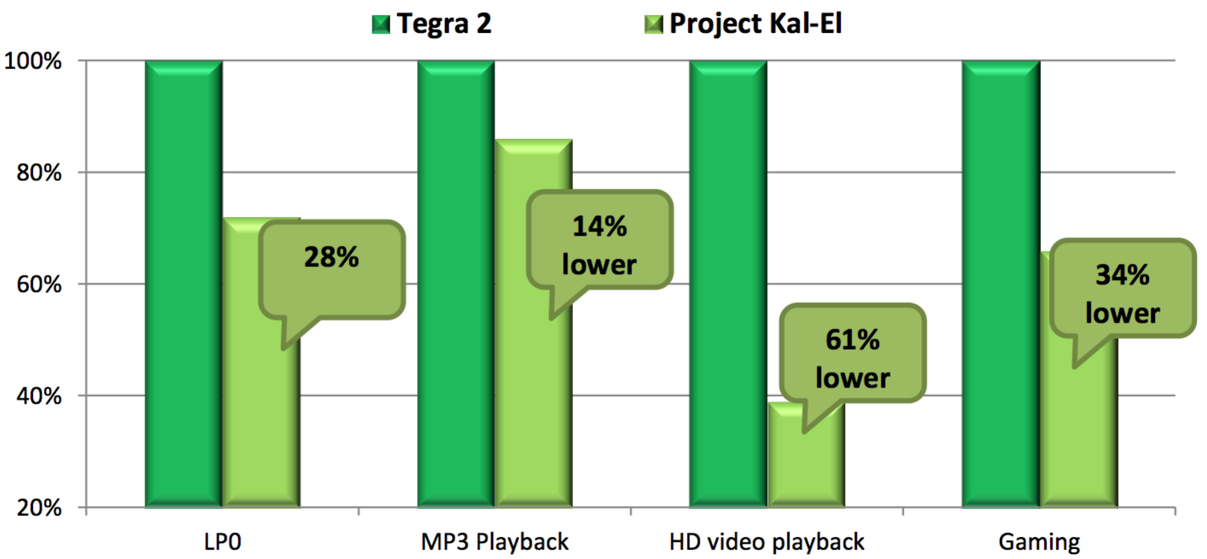

**Figure 3 Power savings Comparison (Source: NVIDIA website)**

In addition to power benefit, multi cores are also capable of improving the CPU performance. Most of modern applications, i.e. the browser Chrome and Firefox are multi-threaded and capable of spawning several concurrent processes. Each page tab in a Chrome browser is a separate process, and each process manages its own set of threads. Both the processes and threads are highly parallelizable. The Android operating system evolved from Linux, and has native support for multitasking and multi-threading. Since Version 3.0, the operating system can dynamically allocate workloads to the appropriate CPU core based on current CPU loads and task/activity priority. This feature could leverage the processing power of multi-core CPUs without compromise the responsiveness.

Abdullah et al. [3] propose a parallel programming approach, which achieving speedup in a big matrices multiplication system, based on the idea of task and data parallelism, running on a quad-core Samsung Galaxy SIII.

**Table 4 Parallel Programming Speed up Result**

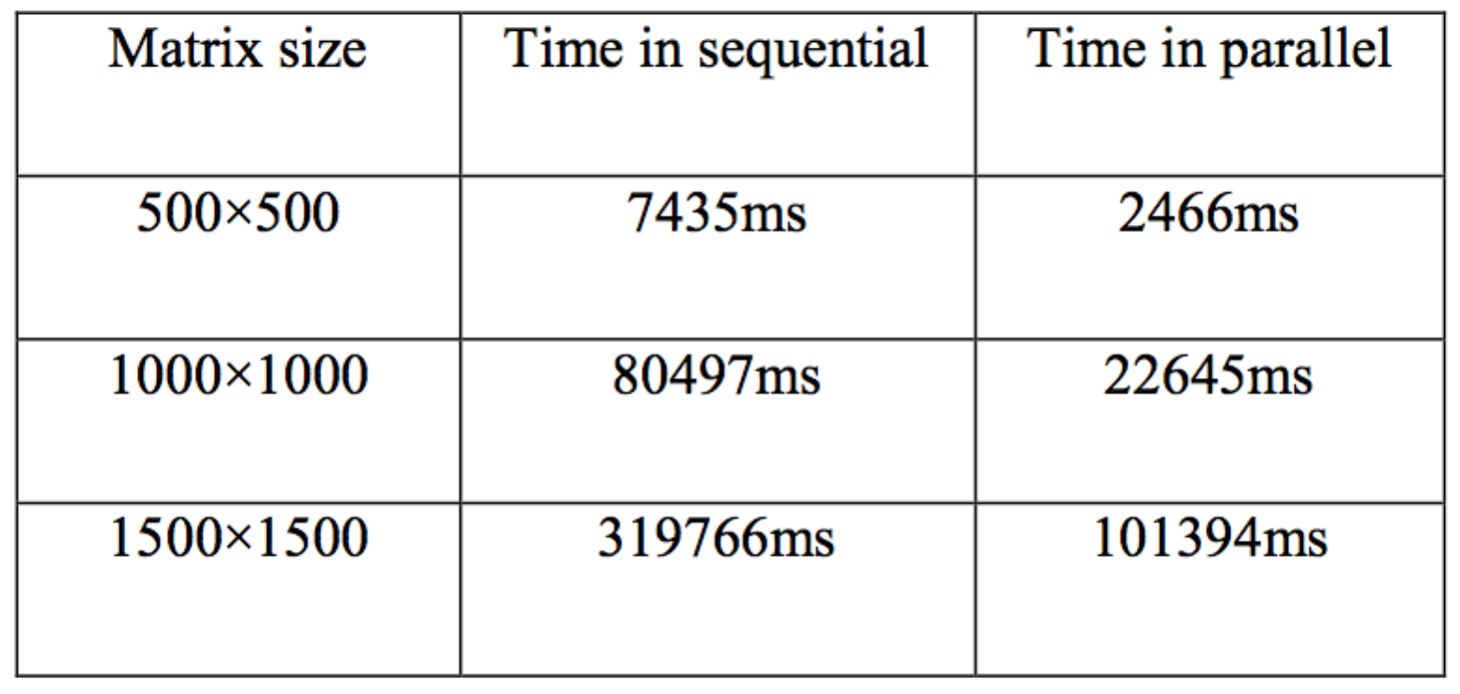

The proposed system shows significant reduction in the overall processing time and great speedup, and illustrates the great advantage of multi-cores processor.

**Cache and Memory Architecture**

Memory requirements in capacity and speed are increasing as smartphones tend to be used for multimedia applications, which place higher demand on the main memory. Some of the most popular applications have a memory requirements range from 2.6MB for a simple Calculator to as much as 13.3MB for Google maps that needs to buffer map data in memory. According to [4], the memory subsystem in a smartphone can consume 34.5% of the overall phones energy when executing applications, resulting in much higher energy consumption than the CPU, which contributes 15.5% to the overall energy consumption.

Due to tremendous growth driving demand for Low-Power DRAM solutions, Low-power DDR (LPDDR), a modified form of DDR SDRAM to reduce overall power consumption, emerged as a mainstream choice for most mobile devices.

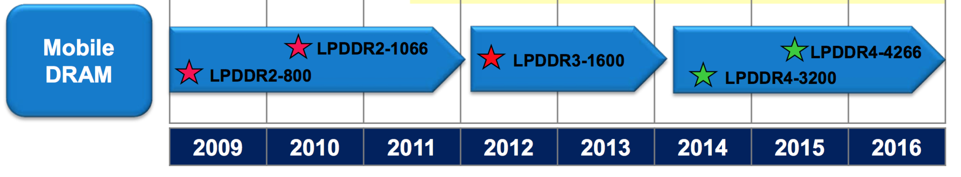

**Figure 4 LP DDR Roadmap**

We are now at the stage of LPDDR3. Most significant, the supply voltage is reduced from 2.5 to 1.2 V which is the key advantage helping reduce power consumption. Additional, LPDDR3 offers a higher data rate (1600 MT/s), greater bandwidth (12.8GB/S) and power efficiency, higher memory density (4GB-16GB) and utilizes key new technologies: write leveling and command/address training, optional on-die termination (ODT), and low-I/O capacitance [5].

Rank is the smallest power management unit in LPDDR and can operate in several different power states: (1) I/O: when memory is reading or writing data; (2) Precharge (PRE): where the next I/O can take place immediately without any delay; (3) Powerdown (PD): where several subcomponents of a rank are disabled to reduce power, such as I/O buffers, sense amplifier, row/column decoder, etc.; (4) Self Refresh (SR): where in addition to Powerdown state, the external clock and on-die termination are disabled to reduce power even further. Figure 5 shows the power states of a rank and their associated transition latencies as well as the energy consumption to perform one bus read or write [6].

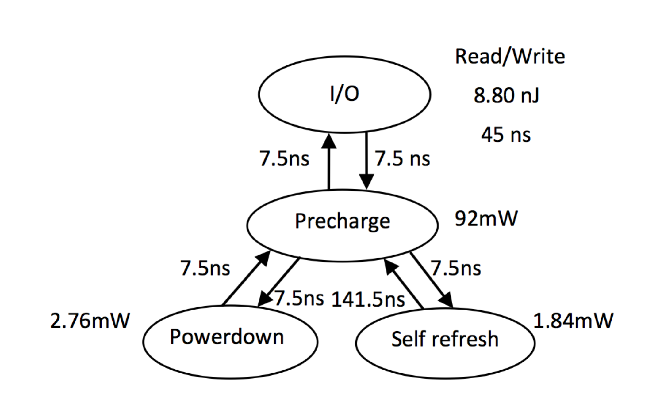

**Figure 5 Power specifications for a 64MB 133MHz PCM device.**

According to figure 5, a rank in the PD state only consumes 1/30 power of PRE state, while the SR state offers 33% additional power reduction to the PD state. The existence of low-power states provides the opportunity to save energy during idle periods.

To further improve the mobile device’s power efficiency and performance, Memory cache plays a primary role. Doubling cache sizes and increasing set associatively can significantly increase cache performance. See figure 6 below:

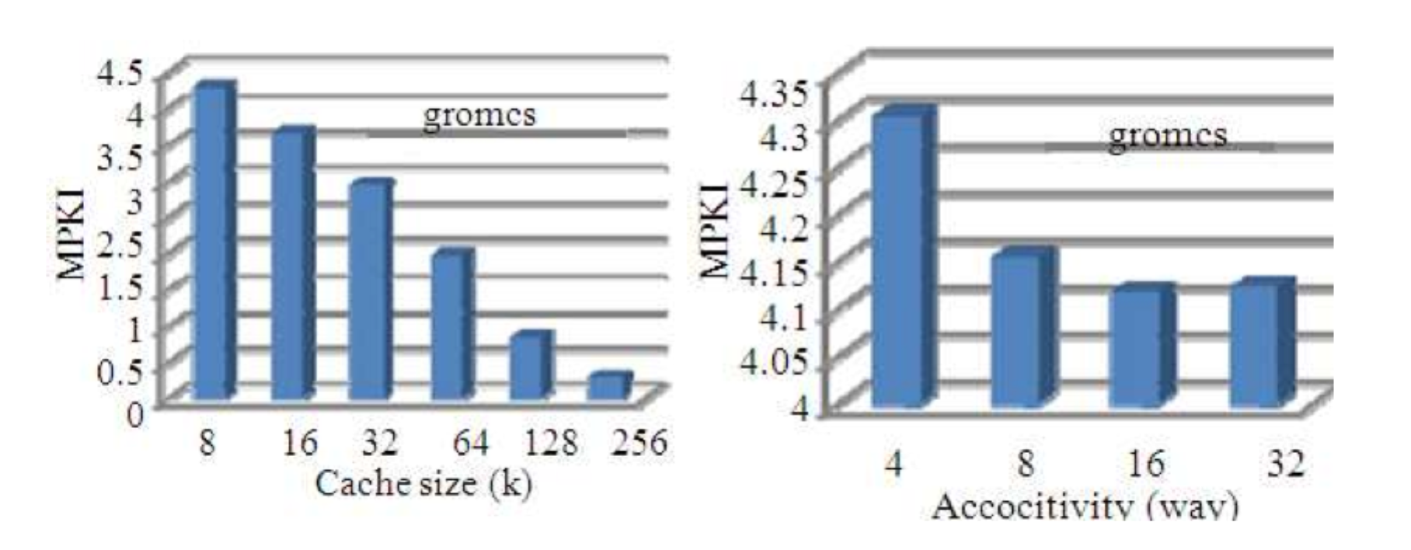

**Figure 6 Cache misses (misses per kilo instruction) with cache size and set associativity variations**

Recent years we do have witnessed widespread use of large sized on-chip caches for achieving high performance. Nowadays, mobile CPUs typically have 16 to 64bits cache separated for instruction and data at level one, while at lower levels (i.e., at level 2 and 3), larger instruction and data caches are unified. However, due to this, total power consumption of processors is rapidly approaching the “power-wall” imposed by thermal limitations of cooling solutions and power delivery. On chip caches consume 16% of the total power in Alpha 21264 and 30% of the total power in StrongARM processor core [7]. In both Niagara and Niagara-2 processors, L2 cache consumes nearly 24% of the total power consumption [8]. Thus, the power consumption of caches is becoming a large fraction of processor power consumption.

The power consumption of cache is mainly classified in two parts, namely dynamic power (also called active power) and leakage power (also called static power). Dynamic power is dissipated whenever transistors switch to change the voltage in a particular node, while leakage power is dissipated due to leakage currents that flow even when the device is inactive. To address the challenges, a substantial amount of research has been directed towards achieving energy efficiency in caches.

Several techniques have been proposed for saving dynamic energy. Some techniques save dynamic energy by reducing the number of accesses to a particular level of cache hierarchy by using additional memory structures. These structures are used either for data storage or prediction of cache access result or for pre-determination of cache access result [9]. Some techniques reduce the number of cache ways accessed in each cache access by either using software information or compiler information, or hardware-based approaches [10]. A few techniques provision accessing frequent (hot) data with lower energy to reduce average dynamic energy of cache access [11]. Some techniques trade-off access time for gaining energy efficiency by performing the various tasks required for cache accesses in sequential manner instead of simultaneously (i.e., in parallel manner)[12]. If a cache hit/miss decision has already been taken, further tasks can be avoided for saving dynamic energy.

The opportunity of saving leakage energy lies in redesigning the circuit to use low-power cells, reducing the total number of transistors or putting some parts of caches into low (or zero) leakage mode. Based on the data retentiveness of turned-off blocks, the leakage energy saving techniques are classified into two broad types, namely state-preserving and state-destroying techniques. The state-preserving techniques [13] turn off a block while preserving its state. This means that when the block is reactivated, it does not need to be fetched from next level of memory. State-destroying techniques [14] do not preserve the state of the turned-off block, but generally save more energy in the low-power states than the state-preserving techniques.

To achieve additional amount of energy saving, cache energy saving techniques have been synergistically integrated with some other approaches, such as DVFS (dynamic volt- age/frequency scaling), data compression prefetching, etc.

**Instruction Set Architecture**

The question of ISA design and specifically RISC vs. CISC ISA was an important concern in the 1980s and 1990s when chip area and processor design complexity were the primary constraints. Today, computing landscape is significantly shaped by smart phone and tablet. And energy and power are the primary design constraints. Thus, the question of weather ISA plays an intrinsic role in performance or energy efficiency is becoming important.

**ARM ISA**

ARM is a family of instruction set architectures for computer processors based on a reduced instruction set computing (RISC) architecture developed by British company ARM Holdings. Typically, a RISC-based computer design approach means ARM processors require significantly fewer transistors than typical CISC x86 processors in most personal computers. This approach naturally reduces costs, heat and power use. These are desirable traits for light, portable, battery-powered devices. In the past decade, ARM ISA has dominated mobile and low-power embedded computing domains. It’s estimated that 95 percent of the world’s smart phones use ARM-based technology in 2010 alone, according to ARM holding.

The 32-bit sub-architecture, ARMv7-A, is the most widely accepted architecture in mobile devices. Except for the standard 32-bit RISC feature, some other highlighted features include 1) New instruction set Thumb-2 added which intend to replace two instructions with signal instruction. Thus result in smaller code and more efficiency cache usage. 2) Backward compatibility with existing software running on earlier ARM cores. 3) Support virtual memory architecture and page tables in memory. 4) VFPv2 – Floating Point support. And increase double precious register count form 16 to 32. 5) Support SIMD instruction, which is designed to accelerate multimedia and DSP application.

The ARM ISA is also evolving. Announced in October 2011, ARMv8-A represents a fundamental change to the ARM architecture. It adds a 64-bit architecture, named "AArch64", and a new "A64" instruction set. ARMv8-A allows 32-bit applications to be executed in a 64-bit OS, and a 32-bit OS to be under the control of a 64-bit hypervisor. Apple launched the ARMv8-A based 64bits SoC A7. While not the first 64-bit ARM CPU, it is the first to ship in a consumer smartphone or tablet computer.

**X86 ISA**

The Intel Atom family is an x86-based architecture with dual in-order instructions. All instructions in the CPU are translated into micro-operations (μ-ops) that contain a memory load and a store operation for each ALU operation. This kind of design is similar to that of traditional x86 architectures but makes use of even more powerful μ-ops than those used in previous designs. Such architecture enables significant performance per cycle for each core without any instruction re-ordering, speculative execution or register re-naming. However, this μ-op architecture increases the branch miss-prediction penalty. Intel's Atom has a 16-stage pipeline, including three instruction phase stages: decode (3 stages), instruction dispatch (2 stages), and data cache access (3 stages). Each Atom core is also equipped with two ALUs and two FPUs. The first ALU manages shift operations, and the second controls jumps. All arithmetic operations, including integer operations, are automatically sent to the FPUs. The first FPU is simple and limited to addition, while the second manages SIMD and multiply/divide operations. While basic instructions are executed in one cycle, it can take up to 31 cycles (for floating point division) for complex instructions. To increase performance, Atom also supports Hyper-Threading. Hyper-Threading is Intel's proprietary technology that implements simultaneous multi-threading. For each processor core that is physically present, the operating system can create two virtual processors and shares the workload between them. Hence a dual-core Atom appears to have four cores to the operating system.

Intel has put significant efforts in reducing the power consumption for the Atom processor family and actually transfer it form a traditional CPU to a SoC. The latest launched Atom 4 cores Z3770D SoC based on 64bit X86 ISA reaches a clocking rate of 2.4GHz with. With the specially optimized 22nm low-power design process with Tri-Gate transistors, performance and energy efficiency has been significantly improved compared to its predecessor with a TDP less than 4W.

**The Comparison Between ARM and X86 based Processors**

Quite a lot study has been done to compare the performance and energy efficiency between the processors based on these two different ISA.

Blem et al. [15] select two chips implementations each for the AMR and X86 ISA to evaluate the processors performance, power, and energy. And compare Cortex-A8 to Atom and Cortex-A9 to i7. The benchmark data is showed below:

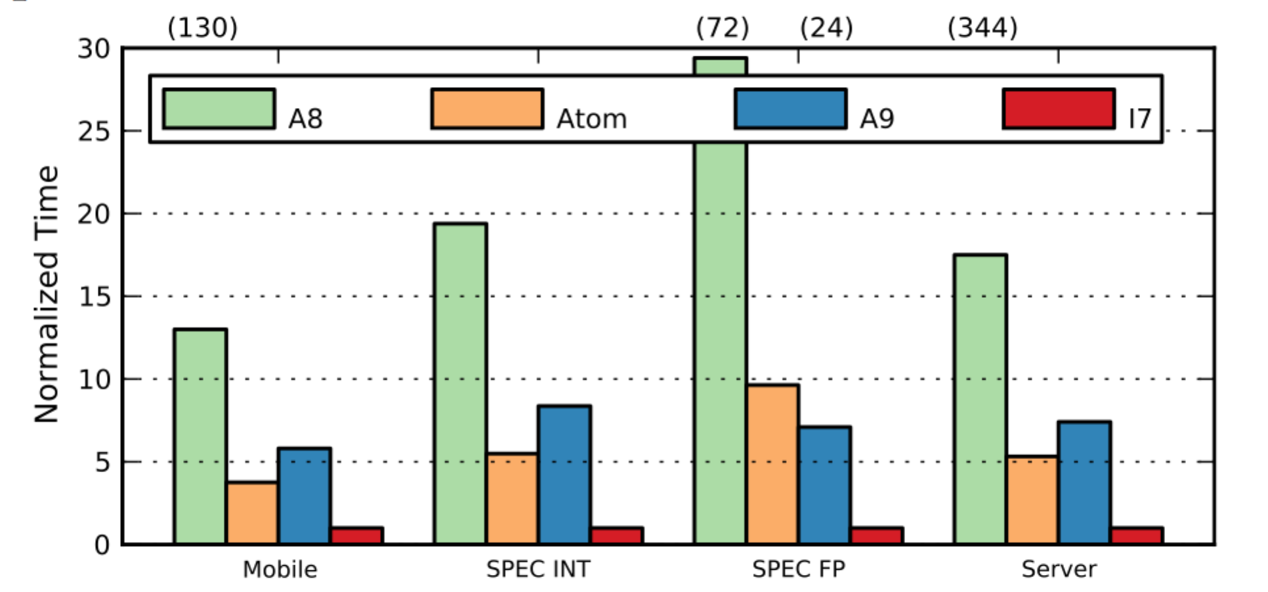

**Figure 7 Execution Time Normalized to i7.**

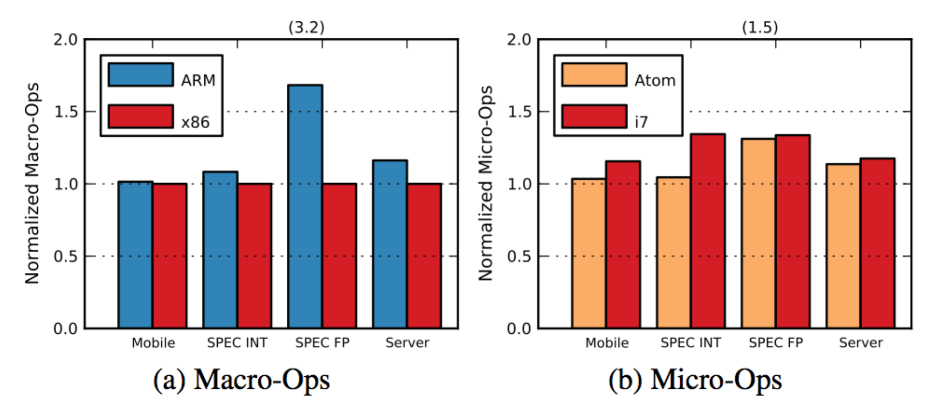

**Figure 8 Instructions Count Normalized to i7 macro-ops.**

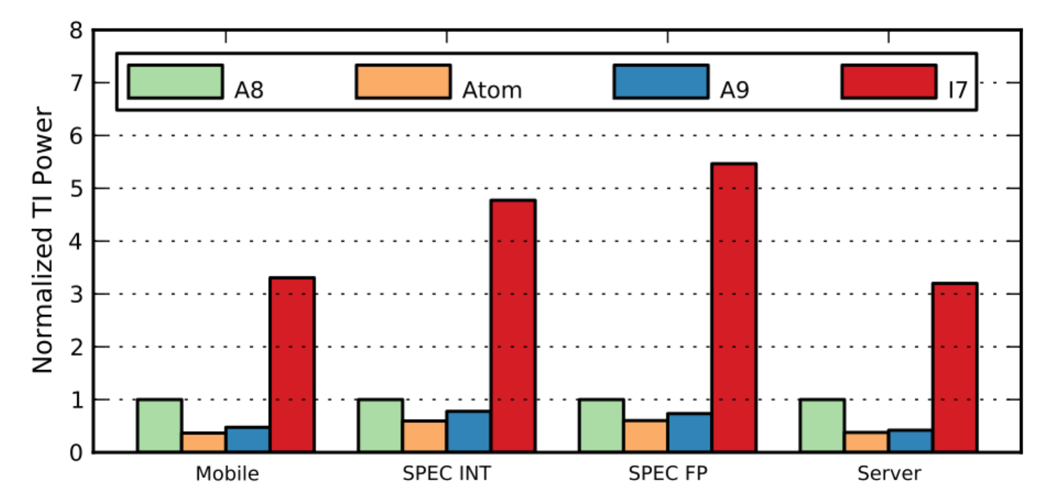

**Figure 9 Tech. Independent Avg. Power Normalized to A8**

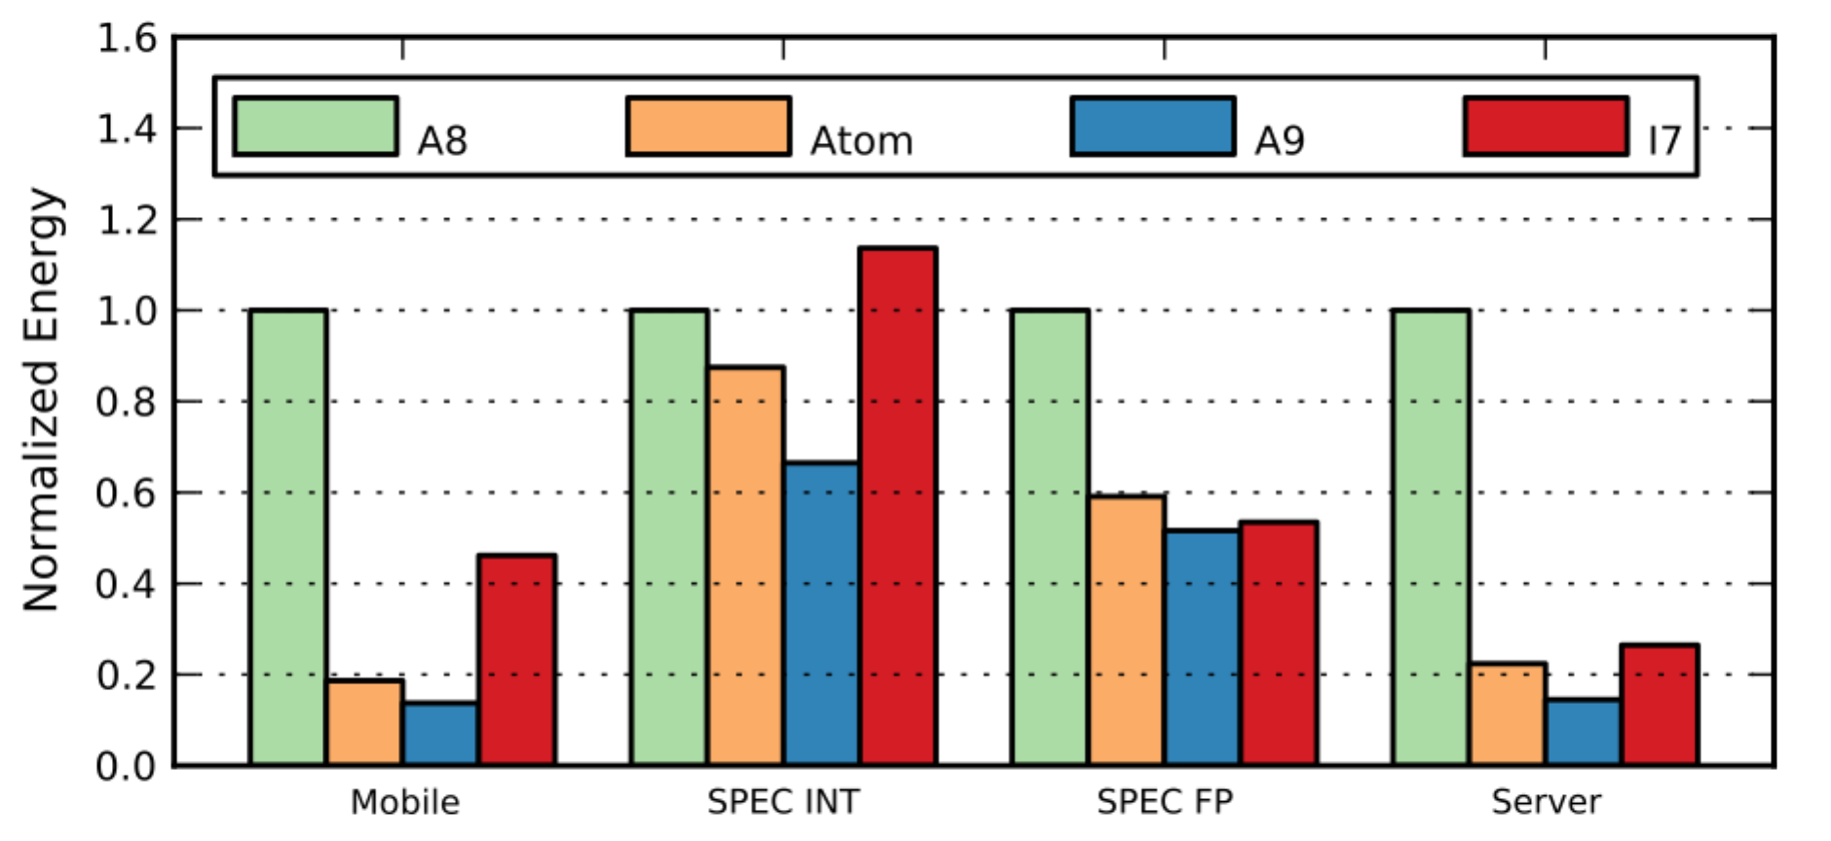

**Figure 10 Raw Average Energy Normalized to A8**

The conclusion was given that ARM and x86 processors are simply engineering design points optimized for different levels of performance, and there is nothing fundamentally more energy efficient in one ISA class or the other. While RISC and CISC ISA traits are irrelevant to power and performance characteristics of modern cores, ISAs continue to evolve to better support exposing workload-specific semantic information to the execution substrate. Decades of hardware and compiler research have enabled efficient handling of both RISC and CISC ISAs and both are equally positioned for the coming years of energy-constrained innovation.

Hoffman and Hedge’s experiment [16] shows the ARM-based Cortex-A8 provides significant power savings while the X86-based Intel Atom‘s pure processing power is unmatched. The Cortex-A8 has considerable advantages in multimedia areas if it is integrated on a system-on- chip device. The figure below shows benchmark performance result form this experiment.

**Table 5 Benchmark Results for BeagleBoard and an Atom 330 Desktop**

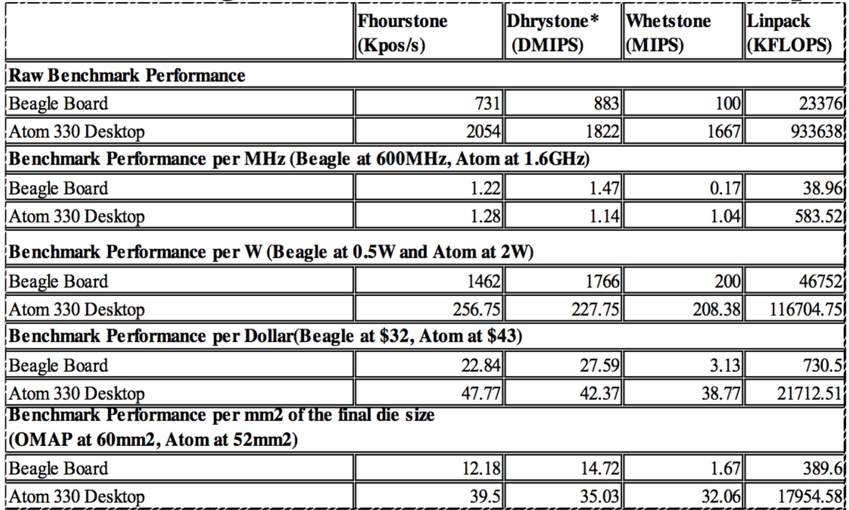

If Intel is able to reduce the processor to less than 1.5W, it will achieve approximately the same performance-per-power as the ARM-based OMAP3530. However they believe the choice of processor may not be limited to the hardware but in software. The X86 based processor may have more advantages due to abundant existing applications and user familiarity.

**CONCLUSION**

Mobile cellular processors are far more constrained in terms of power consumption and area constraint. Due to the increasing demand on performance, the total power consumption of mobile processors is rapidly approaching the "power wall" imposed by limitation of cooling solutions and power delivery. Thus to be able to continue achieving higher performance using technological scaling, ultra- low-power architectural solutions have become a vital necessity helping meet these consumer demands.

In this paper, we have review the several architectural techniques adopted for managing the mobile processors power consumption and balancing the performance. Multicore is more power efficient as it can run at a lower clock frequency. And the heterogeneous architecture allows multi cores to be enabled or disabled separately and independently, which save energy further more.

Memory and Caches contribute a significant amount of the overall power budget. Several proposed solutions were introduced in this paper to address these problems, both in terms of dynamic and leakage power. And contemporary ARM and x86 processors are compared running modern workloads to understand the role of ISA on performance, power, and energy.

As embedded mobile processors continue to spread and become ubiquitous, it is essential to maintain high performance, low power, and small size. The proposed architectural techniques partially fulfill these requirements and enable mobile processors to continue to mature and be able to handle exceedingly complex and aggressive applications. It's hoped that this paper will enable reader to understand the state-of-art in micro architectural techniques for improving mobile processor performance and motivate them to design novel solution for addressing the challenges posed by future trends of CMOS fabrication and processor design.

**REFERENCES**

1. Aitken, R., Flautner, K., & Goodacre, J. (2011). High-Performance Multiprocessor System on Chip: Trends in Chip Architecture for the Mass Market. In *Multiprocessor System-on-Chip* (pp. 223-239). Springer New York.
2. Van Berkel, C. H. (2009, April). Multi-core for mobile phones. In *Proceedings of the Conference on Design, Automation and Test in Europe* (pp. 1260-1265). European Design and Automation Association.
3. Abdullah, D. B., & Al-Hafidh, M. M. (2013). The True Powers of Multi-core Smartphones. *International Journal of Computer Science Issues (IJCSI)*, *10*(4).
4. Rice, A., & Hay, S. (2010, March). Decomposing power measurements for mobile devices. In *Pervasive Computing and Communications (PerCom), 2010 IEEE International Conference on* (pp. 70-78). IEEE.
5. Bae, Y. C., Park, J. Y., Rhee, S. J., Ko, S. B., Jeong, Y., Noh, K. S., ... & Oh, K. (2012, February). A 1.2 V 30nm 1.6 Gb/s/pin 4Gb LPDDR3 SDRAM with input skew calibration and enhanced control scheme. In *Solid-State Circuits Conference Digest of Technical Papers (ISSCC), 2012 IEEE International* (pp. 44-46). IEEE.
6. Duan, R., Bi, M., & Gniady, C. (2011, July). Exploring memory energy optimizations in smartphones. In *Green Computing Conference and Workshops (IGCC), 2011 International* (pp. 1-8). IEEE.
7. Vardhan, A., & Srikant, Y. (2013). Exploiting critical data regions to reduce data cache energy consumption. *Indian Institute of Science, Bangalore, Tech. Rep*.
8. Li, S., Ahn, J. H., Strong, R. D., Brockman, J. B., Tullsen, D. M., & Jouppi, N. P. (2009, December). McPAT: an integrated power, area, and timing modeling framework for multicore and manycore architectures. In *Microarchitecture, 2009. MICRO-42. 42nd Annual IEEE/ACM International Symposium on* (pp. 469-480). IEEE.
9. Inoue, K., Ishihara, T., & Murakami, K. (1999, August). Way-predicting set-associative cache for high performance and low energy consumption. In*Proceedings of the 1999 international symposium on Low power electronics and design* (pp. 273-275). ACM.
10. Inoue, K., Ishihara, T., & Murakami, K. (1999, August). Way-predicting set-associative cache for high performance and low energy consumption. In*Proceedings of the 1999 international symposium on Low power electronics and design* (pp. 273-275). ACM.
11. Udipi, A. N., Muralimanohar, N., & Balasubramonian, R. (2009, December). Non-uniform power access in large caches with low-swing wires. In *High Performance Computing (HiPC), 2009 International Conference on* (pp. 59-68). IEEE.
12. Powell, M. D., Agarwal, A., Vijaykumar, T. N., Falsafi, B., & Roy, K. (2001, December). Reducing set-associative cache energy via way-prediction and selective direct-mapping. In *Proceedings of the 34th annual ACM/IEEE international symposium on Microarchitecture* (pp. 54-65). IEEE Computer Society.
13. Flautner, K., Kim, N. S., Martin, S., Blaauw, D., & Mudge, T. (2002). Drowsy caches: simple techniques for reducing leakage power. In *Computer Architecture, 2002. Proceedings. 29th Annual International Symposium on* (pp. 148-157). IEEE.
14. Powell, M., Yang, S. H., Falsafi, B., Roy, K., & Vijaykumar, T. N. (2000, August). Gated-V dd: a circuit technique to reduce leakage in deep-submicron cache memories. In *Proceedings of the 2000 international symposium on Low power electronics and design* (pp. 90-95). ACM.
15. Blem, E., Menon, J., & Sankaralingam, K. (2013). A detailed analysis of contemporary arm and x86 architectures. *Report, UW-Madison Technical*.
16. Roberts-Hoffman, K., & Hegde, P. (2009). ARM cortex-a8 vs. intel atom: Architectural and benchmark comparisons. *Dallas: University of Texas at Dallas*.